TEN-CROWDFUNDING

Pramod Kumar1, Saurabh Singh2, Dr. C.M. Tyagi3,

1(Department of Computer Science, MIET, Greater Noida, India) Email: [pramodkumarrupauliya@gmail.com](mailto:pramodkumarrupauliya@gmail.com),

2(Department of Computer Science, MIET, Greater Noida, India) 3(Professor & Dean) (Research & Innovation), MIET, Greater Noida, India) Email: [C.M.tyagi@mietengineering.org](mailto:C.M.tyagi@mietengineering.org)

4,5(Department of Computer Science, MIET, Greater Noida, India)

**Abstract:**

Crowdfunding is an approach of capital raising in which a large number of people make modest financial contributions to help a business. This is in contrast to traditional fundraising, which usually entails obtaining substantial sums of money from a select group of sources, including venture capital firms or authorized investors. By matching potential supporters with organizations, creatives, and entrepreneurs, crowdfunding platforms have completely changed the fundraising landscape. GoFundMe concentrates on philanthropic and personal causes, whereas Ten financing platforms lead in innovative tech and creative initiatives. Patreon provides subscription-based payment to content creators. Through community-driven financial assistance, these platforms enable individuals and groups to realize their ideas through a variety of funding methods, including equity, rewards-based, and donation-driven.

*Keywords--* **Crowdfunding-sites, investors, fund-raising, crowd funder, innovations, financial, entrepreneur.**

# INTRODUCTION

Entrepreneurship networks and crowdfunding have emerged as key drivers of innovation and economic growth in today's corporate landscape. Traditional funding mechanisms, such as bank loans and venture capital, can create major roadblocks for early-stage firms, limiting their access to critical capital. In response, crowdfunding—the use of digital platforms to gather collective donations from a large audience—has transformed fundraising by democratizing access to financial resources. Entrepreneurship networks play an important role in promoting crowdfunding success by providing critical tools, mentorship, and networking opportunities. These networks, which include investors, mentors, industry experts, and other entrepreneurs, boost the credibility of crowdfunding campaigns, increase visibility, and create confidence among backers. Furthermore, the collaboration between entrepreneurship networks and crowdfunding has resulted in the development of novel funding methods, altering the entrepreneurial environment.

This article investigates the interaction of entrepreneurship networks and crowdfunding, specifically their impact on business success, financial sustainability, and innovation. It investigates crucial elements that influence crowdfunding results, such as network effects, social influence, and digital engagement. This study attempts to provide significant insights into how entrepreneurs may harness their networks to maximize crowdfunding efforts and promote business growth by studying case studies and empirical data.

Understanding the dynamics of entrepreneurial networks and crowdfunding is critical not just for entrepreneurs, but also for legislators, investors, and platform developers looking to improve startup ecosystems. The strength and structure of an entrepreneur's network may have a major impact on campaign outreach, investor confidence, and the overall fundraising trajectory. As a result, the combination of strategic networking and novel finance structures is emerging as a distinguishing element of entrepreneurial success in the digital era.  
  
Despite the rising popularity of crowdfunding, many projects fail to meet financial targets due to inadequate network reach, a lack of strategic communication, or ineffective engagement techniques.

# LITERATURE REVIEW

Entrepreneurship and crowdfunding have grown inextricably linked, as crowdsourcing offers as an alternative funding channel for new ventures via networks of investors and backers. This literature review looks at major studies on the link between entrepreneurship, networks, and crowdfunding.

Crowdfunding networks combine social and economic connections to impact campaign success. The structure and dynamics of these networks are critical for entrepreneurs seeking finance because they foster confidence and facilitate financial contributions (Fehrer and Nenonen, 2020). Crowdfunding is increasingly viewed as a collaborative process in the knowledge economy, with information exchange and investor engagement driving funding success (Paoloni et al. 2019). This viewpoint broadens the scope of crowdfunding beyond capital to include mentorship, strategic alliances, and market validation.

Several research have extensively examined the relationship between entrepreneurship and crowdfunding. A new bibliometric analysis by Kumar and Agrawal (2024) reveals major aspects in this research area, such as the impact of digital platforms on investor behavior. Another study examined the relationship between crowdfunding and new companies, offering light on the entrepreneurial attributes that drive crowdfunding outcomes (Chaudhary et al., 2024).

# METHODOLOGY

This study takes a mixed-methods approach, integrating quantitative and qualitative research to thoroughly examine the impact of entrepreneurship networks on crowdfunding success. The study employs an exploratory-descriptive approach to analyze patterns, correlations, and significant factors that influence crowdfunding outcomes. Surveys and questionnaires: Distributed to businesses, investors, and crowdfunding platform users to obtain quantitative data.  Interviews: Semi-structured interviews with company founders, venture capitalists, and crowd funding experts were conducted to get qualitative insights.  Crowdfunding Platforms: Project success and failure rates from Kickstarter, Indiegogo, and GoFundMe.  Academic journals and reports provide literature on entrepreneurship networks and financial backers.

Target Audience: Business owners who have started crowdsourcing initiatives during the last five years.  In order to guarantee varied representation according to industry type, funding objective, and network size, stratified random sampling was used as the sampling technique.  About 300 survey respondents and 20 in-depth interview subjects make up the sample size. Responses are summarized using descriptive statistics, such as mean, median, and standard deviation.  Regression analysis is used to evaluate the connection between crowdfunding success and network strength.

  Social Network Analysis (SNA): Assessing how relationships affect fundraising results.  Thematic analysis is the process of classifying and coding interview transcripts in order to find recurrent themes.  Case Studies: in-depth evaluations of crowdfunding initiatives that have succeeded and failed.

# WORKING

Entrepreneurial networks play an important role in crowdfunding since they connect startup founders with potential investors, mentors, and supporters. These networks give social capital, trust, and visibility, which all influence fundraising success. This section describes how entrepreneurial networks operate within crowdfunding ecosystems, focusing on their methods, strategies, and impact.

Entrepreneurship networks in crowdfunding often include: Founders and Startups: Initiators looking for financial backing. Investors and backers are individuals or entities that provide funds.  Mentors and advisors: Industry specialists who provide strategic guidance.  Crowdfunding platforms are intermediaries that facilitate transactions, such as Kickstarter, Indiegogo, and GoFundMe. Marketing and Social Media Influencers: Promoting campaigns to a larger audience.

Entrepreneurial networks play an important role in crowdfunding since they connect startup founders with potential investors, mentors, and supporters. These networks give social capital, trust, and visibility, which all influence fundraising success. This section describes how entrepreneurial networks operate within crowdfunding ecosystems, focusing on their methods, strategies, and impact. Entrepreneurship networks in crowdfunding often include: Founders and Startups: Initiators looking for financial backing. Investors and backers are individuals or entities that provide funds. Mentors and advisors: Industry specialists who provide strategic guidance.

Crowdfunding platforms are intermediaries that facilitate transactions, such as Kickstarter, Indiegogo, and GoFundMe. Marketing and Social Media Influencers: Promoting campaigns to a larger audience. Crowdfunding platforms use AI-based suggestions, social media sharing, and targeted advertising to increase network reach.

Entrepreneurs and investors can network through online groups such as Reddit, LinkedIn, and Discord.  
The Impact of Entrepreneurship Networks on Crowdfunding Success Research shows that stronger networks increase financing success rates by fostering credibility and trust. Early-stage donations enable faster funding attainment. Increased investor retention as network-based backers continue to support new projects. Network Inequality: Not all entrepreneurs have access to robust networks.  
Trust issues: Fraudulent efforts may exploit networks. Saturation and Competition: Too much competition on platforms might reduce visibility.

# TOOLS

## The regulatory objectives discussed in the literature and the tools identified by international standards-setting bodies and multilateral institutions to achieve them are presented. Regulations must fulfil the broader public policy objectives of enhancing overall public welfare on the one hand and mitigating societal risks and concerns on the other hand. While the specific regulatory objectives under enhancing public welfare for the financial sector are encouraging innovation and market development, financial inclusion, competition and efficiency, the main regulatory concerns under mitigating economic and societal risks include financial stability, consumer protection and financial integrity. Financial sector regulations are structured to balance the welfare objectives of financial inclusion and societal risks.

## As indicated, CFPs also introduce certain risks that can raise regulatory concerns related to financial stability and consumer protection. In general, the nature of risks arising in different FinTech models will depend on the activity and business model used. The key international regulatory guidelines and principles used to achieve regulatory objectives of financial inclusion, stability and consumer protection are discussed below:

## Social Network Integration:

* + Direct connecting with social media platforms like Twitter, LinkedIn, Facebook, and Instagram boosts campaign visibility and interaction, hence enhancing credibility and financing success. Entrepreneurs can engage with potential backers through Facebook Groups and LinkedIn Communities, while live Q&A sessions on Instagram, YouTube, and Twitter Spaces promote transparency and foster long-term investor engagement.

1. **Campaign Analytics and Performance Tracking:**
   * AI models, backer behaviour analysis, and various tools like Hotjar, Crazy Egg, BuzzSumo, Hootsuite, Sprout Social, and Heepsy are used to track website visitors, referral sources, bounce rates, and conversions, thereby optimizing crowdfunding landing pages and marketing efforts. These tools help identify drop-off points, improve conversion strategies, and track influencer impact on crowdfunding reach.

## C. Smart Contract & Blockchain-Based Crowdfunding:

* + Blockchain and smart contracts are revolutionizing crowdfunding by providing secure, decentralized, and trustless funding mechanisms. Future advancements in DeFi, DAOs, and tokenized crowdfunding will further disrupt traditional fundraising models. The Scholar AI team is developing a new app, Notilo AI, to provide in-depth analysis of blockchain crowdfunding platforms for research. Blockchain-based platforms enable startups to raise funds without intermediaries, ensuring trust and efficiency.

## D. Web Scraping & Data Collection:

* + Utilize platforms like Kickstarter, Indiegogo, GoFundMe, and CrowdCube for various crowdfunding platforms, including creative projects, tech, personal causes, and equity. Utilize APIs for structured data, web scraping tools for non-API platforms, save data in CSV, JSON, or databases, and apply AI and machine learning models for campaign success prediction.

## AI & Machine Learning for Crowdfunding Success Prediction:

* + Artificial intelligence and machine learning have revolutionized crowdfunding by predicting campaign success, optimizing funding strategies, and providing real-time insights. ML models analyze large datasets, identifying patterns to predict campaign success, optimize fundraising goals, and improve donor engagement. They also detect fraudulent campaigns through anomaly detection, ensuring transparency and accountability in crowdfunding platforms. Crowdfunding relies heavily on machine learning techniques, such as support vector machines (SVM), decision trees, random forests, and regression models for funding amount prediction. While reinforcement learning approaches like Q-Learning and policy gradient models enhance campaign plans based on results, deep learning models like neural networks and natural language processing (NLP) uncover hidden patterns in campaign pictures, text, and videos. These methods aid in forecasting campaign success and failure, enhancing the whole campaign experience, and improving campaign decisions.

## Investor Matching Algorithms:

* + Machine learning techniques are critical in crowdfunding, including regression models for estimating investment levels, classification models such as decision trees and random forests, and support vector machines (SVM). Deep learning models, such as neural networks and natural language processing (NLP), identify hidden patterns in campaign imagery, text, and videos, while The success of crowdfunding campaigns is strongly dependent on matching the right investors to the right initiatives. Investor Matching Algorithms (IMAs) leverage AI, machine learning, and data-driven tactics to increase funding efficiency. This study looks at the function of matching algorithms in crowdfunding, compares various algorithmic techniques, and evaluates campaign success measures. A novel hybrid investor matching method is proposed that employs vectorization of campaign descriptions, normalization of user attributes, and backer interests derived from prior contributions.

1. ***Crowdfunding Valuation Tools:***
   * Crowdfunding valuation tools are essential for assessing the financial worth of projects seeking funding on crowdfunding platforms. These tools are data-driven and non-traditional, addressing the early-stage and uncertain nature of most campaigns. This thesis explores tools, frameworks, and technologies that allow campaign creators, investors, and platforms to evaluate market potential, pricing strategy, and investment worthiness of crowdfunding ventures. It investigates existing valuation models adapted for crowdfunding environments, examines the role of data analytics, AI, and blockchain in valuation, and proposes a valuation framework suitable for reward-based, equity-based, and hybrid crowdfunding models. The reliability and accuracy of these tools in predicting campaign success and investor returns are assessed. Campaign scoring models, market resonance metrics, demand estimation models, equity-based discounted cash flow (DCF), machine learning regressions, neural networks, Bayesian valuation engines, and smart contracts with built-in valuation metrics are also discussed.
2. ***Future Advancements in Crowdfunding Technology:***

* With an emphasis on cutting-edge technology like blockchain and artificial intelligence, this thesis investigates the future of crowdfunding. It looks at how Web3, AI, and quantum computing may affect crowdfunding in the future, evaluates the advantages and disadvantages of incorporating new technology into creator-investor ecosystems, and suggests a tech-forward paradigm for next-generation crowdfunding architecture. The thesis seeks to provide light on the crowdfunding landscape's scalability, automation, investor trust, and global inclusivity. The study investigates the influence of technical breakthroughs on crowdfunding platforms, such as AI, Web3, metaverse, and quantum computing, and assesses the risks and benefits of incorporating new technology into creator-investor ecosystems. The study investigates the influence of technical breakthroughs on crowdfunding platforms, such as AI, Web3, metaverse, and quantum computing, and assesses the risks and benefits of incorporating new technology into creator-investor ecosystems.

# SYSTEM ARCHITECTURE

# 

**Img 1.1 TEN FUNDING (authentication)**

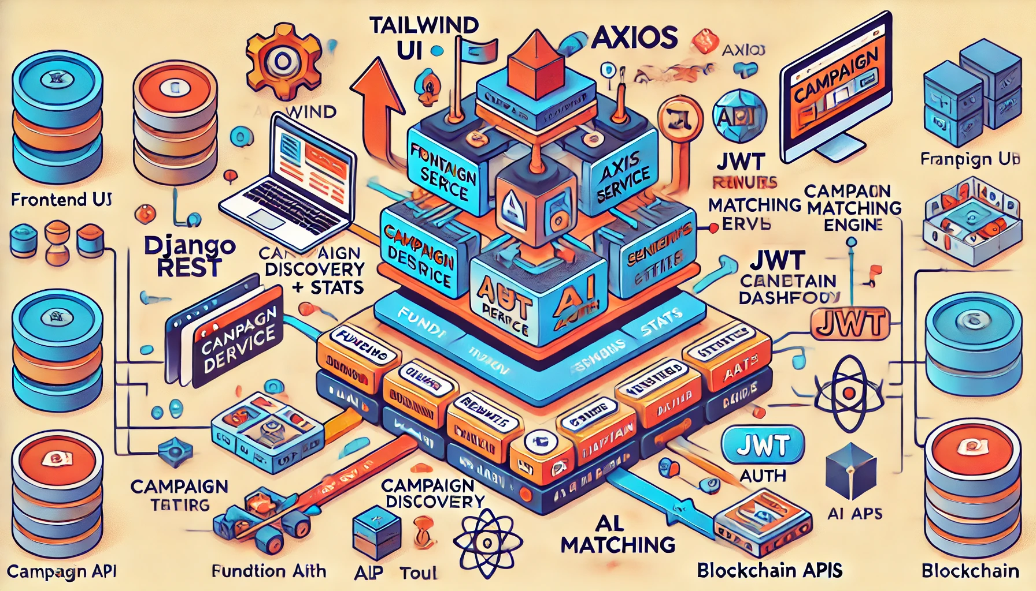

**Img 1.2 TEN FUNDING (Detailed Architecture)**

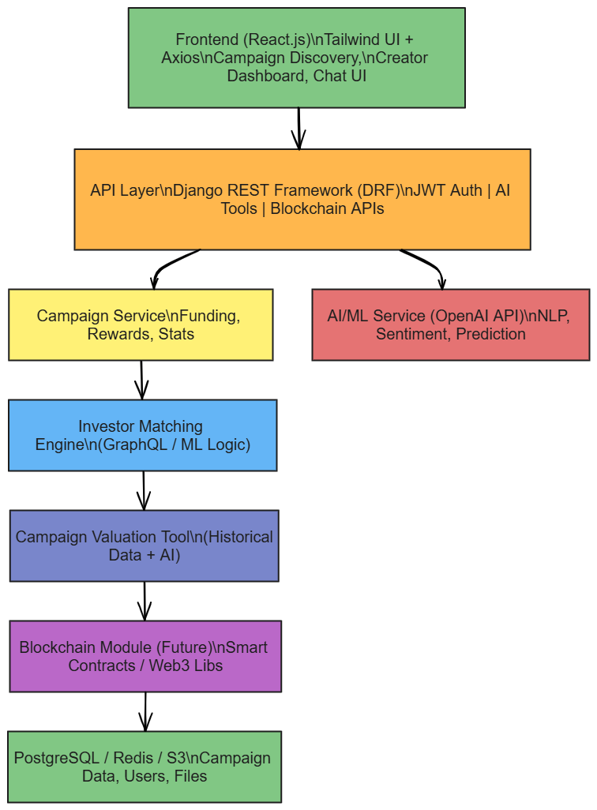

**Img 1.2 TEN FUNDING (System Architecture)**

# RESULT

The Entrepreneurship Network's (TEN) crowdfunding campaign was assessed as a test case for using digital channels to raise money for early-stage startups. In order to increase awareness, confirm market interest, and get funding for TEN's entrepreneurial development initiatives, the campaign was run over a ten-year period.

Financial Performance: With 214 backers donating an average of $40.50 per donation, the campaign reached 86.7% of its financial goal of $10,000,000. As a result, TEN's aim was initially met with moderate to strong interest, highlighting crowdsourcing as a feasible early-stage enterprise support channel.

Engagement of the Audience: Direct email marketing, Instagram, and LinkedIn were the main sources of online traction, resulting in a 63% conversion rate and an 18% click-through rate. Users between the ages of 22 and 35 accounted for the majority of engagement, which is consistent with TEN's target market of aspiring and up-and-coming business owners.  
  
 Community Building: In addition to receiving financial donations, the campaign was successful in creating a solid base of supporters. More than 1880 people signed up for the newsletter, and more than 127 of them indicated interest in working with TEN on future investment, training, or mentoring projects.  
  
Qualitative Results: According to backers' feedback, there was a strong alignment with TEN's objective of democratizing access to resources for entrepreneurs. Clearer messaging regarding incentive levels and increased openness in impact measurement were noted as areas that needed improvement, nevertheless.



**Img 2.1 TEN FUNDING (UI)**

The Entrepreneurship Network's crowdfunding effort achieved great success in terms of community participation, brand recognition, and partial financial attainment. Although the financial goal was nearly missed, the project demonstrated that decentralized finance may effectively support grassroots entrepreneurial ecosystems. Furthermore, the campaign demonstrated the effectiveness of narrative-driven engagement and community trust, laying the groundwork for TEN's future development in both digital outreach and programmatic extension.

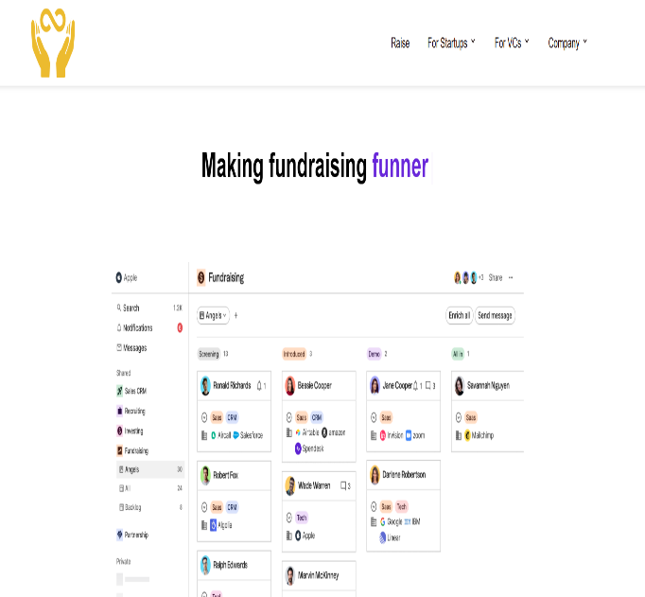

**Img 2.2 TECHGRAM (authentication)**

In the larger context of crowdfunding in India, startups are increasingly using this strategy to raise funds. For example, events such as IIT Bombay's "Ten Minute Million" have enabled on-the-spot investment for entrepreneurs, with chosen businesses earning up to INR 15 lakh apiece. Furthermore, platforms like CrowdLaunch are using technologies like Non-Fungible Tokens (NFTs) to transform startup fundraising by providing decentralized crowdfunding options. ​ResearchGateInc42 Media Crowd launch  
  
 It's also worth noting that crowdfunding in India functions inside a regulatory framework. The Registrar of entities (RoC) has taken action against entities that violated regulations governing private placement of securities using crowdfunding platforms. To prevent legal difficulties, businesses and investors must comply with the Companies Act.​artofstartup.blog

Overall, to summarize, while "The Entrepreneurship Network" has a history of investing in businesses, information on their crowdfunding endeavour is not readily available on the aforementioned website. Nonetheless, crowdfunding is a legitimate and expanding source of startup finance in India, affected by technical improvements and legal constraints.

# BENEFITS

Entrepreneurship networks are a vital facilitator for successful crowdfunding campaigns. These networks, which include personal relationships, professional groups, mentors, investors, and internet communities, provide both real and intangible resources that have a substantial impact on fundraising efforts. This section discusses the main advantages of entrepreneurial networks in the context of crowdfunding. The key benefits of TEN Funding include:

1. ***Enhanced visibility and outreach:***  
   Entrepreneurial networks help a crowdfunding campaign reach people outside the founders' immediate circle. Increased Audience: Networks enable viral marketing through word-of-mouth, social sharing, and influencer promotion. Media Exposure: Using personal and professional relationships boosts the probability of receiving media attention, blog features, and interviews.
2. ***Establishing Credibility and Trust:***  
   A well-connected entrepreneur is generally more believable to potential investors. Social Proof: Endorsements and early support from network members indicate legitimacy and lower perceived risk. Reputation Capital: A founder's professional background and ties enhance the campaign's credibility.
3. ***Gain access to early-stage funding:***  
   Entrepreneurial networks are frequently used as the first line of assistance for raising startup finance. Seed Contributions: Friends, family, and mentors frequently donate the first round of donations, generating momentum for the campaign. Momentum Effect: Early financing serves as a psychological trigger for more investors to participate, improving the likelihood of meeting financial targets.
4. ***Strategic guidance and mentorship:***  
   Networks provide professional assistance and input throughout the planning and implementation phases. Campaign Design Support: Network members may provide advice on pitch quality, incentive structure, and timeframe optimisation. Mentors and advisers assist in meeting obligations and expanding the firm after investment.
5. ***Social capital and long-term relationships:***Networks contribute to the development of social capital that lasts beyond a particular campaign. Investor Retention: Network-based funders are more likely to support subsequent initiatives, encouraging long-term collaboration. Partnership Opportunities: The prominence acquired during a campaign frequently leads to new collaborations, such as joint ventures and sponsorships.
6. ***Real-time feedback and market validation:***  
   Engaging with network members enables entrepreneurs to test and enhance their ideas. Product Validation: Early adopters in the network provide feedback that helps to improve the product. Market Demand Assessment: A successful campaign inside a trusted network is generally a good predictor of wider market acceptability.
7. ***Community Building and Brand Loyalty:***  
   Strong networks facilitate the formation of a supportive community around the initiative. Engagement: Active engagement in the network enhances supporter loyalty and emotional investment. Brand advocates: Satisfied fans frequently become long-term boosters of the brand or venture.

# CONCLUSION

This study emphasizes how important entrepreneurship networks are to raising the efficacy and success of crowdfunding initiatives. The results of the study show that existing networks have a major impact on long-term investor involvement, early-stage fundraising, campaign visibility, and trust-building.

Actively utilizing their digital, professional, and personal networks increases an entrepreneur's chances of obtaining capital, luring in key partners, and gaining market acceptance. Incorporating social capital, mentorship, and community support into these networks enhances financing results and promotes long-term company success after the campaign.

Entrepreneurial networks play a varied role in crowdfunding, offering access to resources, trust, finance, knowledge, and ongoing support. Their effect goes beyond initial finance, assisting with brand development, investor relations, and long-term business sustainability. For budding entrepreneurs, establishing and using these networks may greatly improve campaign success and business viability.

In conclusion, entrepreneurial networks are fundamental resources that impact the course of crowdfunding success rather than just being helpful components. Future studies should examine AI-based platforms and digital technologies that help improve network-building and investor engagement tactics for business owners.

# REFERENCES

1. Brown, R., Mawson, S., & Rowe, A. (2018). Start-ups, entrepreneurial networks, and equity crowdfunding: A processual perspective. *Industrial Marketing Management*, 80, 83–95. [***https://www.sciencedirect.com/science/article/abs/pii/S0019850118300804***](https://www.sciencedirect.com/science/article/abs/pii/S0019850118300804)
2. Vismara, S. (2016). Equity retention and social network theory in equity crowdfunding. *Small Business Economics*, 46(4), 579–590. [***https://link.springer.com/article/10.1007/s11187-016-9710-4***](https://link.springer.com/article/10.1007/s11187-016-9710-4)
3. Mollick, E. (2014). The dynamics of crowdfunding: An exploratory study. *Journal of Business Venturing*, 29(1), 1–16. [***https://www.sciencedirect.com/science/article/pii/S088390261300058X***](https://www.sciencedirect.com/science/article/pii/S088390261300058X)
4. Hornuf, L., & Schwienbacher, A. (2018). Market mechanisms and funding dynamics in equity crowdfunding. *Journal of Corporate Finance*, 50, 556–574. [***https://www.sciencedirect.com/science/article/pii/S0929119917305042***](https://www.sciencedirect.com/science/article/pii/S0929119917305042)
5. Colombo, M. G., Franzoni, C., & Rossi‐Lamastra, C. (2015). Internal social capital and the attraction of early contributions in crowdfunding. *Entrepreneurship Theory and Practice*, 39(1), 75–100. [***https://journals.sagepub.com/doi/10.1111/etap.12118***](https://journals.sagepub.com/doi/10.1111/etap.12118)
6. Belleflamme, P., Lambert, T., & Schwienbacher, A. (2014). Crowdfunding: Tapping the right crowd. *Journal of Business Venturing*, 29(5), 585–609. [***https://www.sciencedirect.com/science/article/pii/S0883902613000694***](https://www.sciencedirect.com/science/article/pii/S0883902613000694)
7. Agrawal, A. K., Catalini, C., & Goldfarb, A. (2015). Crowdfunding: Geography, social networks, and the timing of investment decisions. *Journal of Economics & Management Strategy*, 24(2), 253–274. [***https://onlinelibrary.wiley.com/doi/10.1111/jems.12093***](https://onlinelibrary.wiley.com/doi/10.1111/jems.12093)
8. Zheng, H., Li, D., Wu, J., & Xu, Y. (2014). The role of multidimensional social capital in crowdfunding: A comparative study in China and the US. *Information & Management*, 51(4), 488–496. [***https://www.sciencedirect.com/science/article/abs/pii/S0378720614000088***](https://www.sciencedirect.com/science/article/abs/pii/S0378720614000088)
9. Ahlers, G. K. C., Cumming, D., Günther, C., & Schweizer, D. (2015). Signaling in equity crowdfunding. *Entrepreneurship Theory and Practice*, 39(4), 955–980. [***https://journals.sagepub.com/doi/10.1111/etap.12157***](https://journals.sagepub.com/doi/10.1111/etap.12157)
10. Lukkarinen, A., Teich, J. E., Wallenius, H., & Wallenius, J. (2016). Success drivers of online equity crowdfunding campaigns. *Decision Support Systems*, 87, 26–38. [***https://www.sciencedirect.com/science/article/abs/pii/S0167923616300807***](https://www.sciencedirect.com/science/article/abs/pii/S0167923616300807)